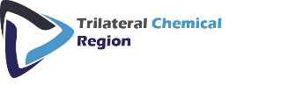
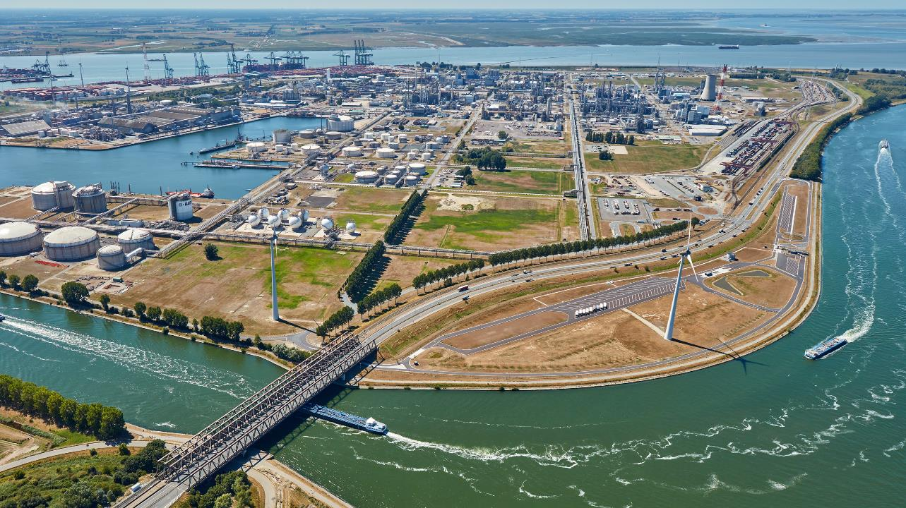
REGISTRATION

Digitalization and automation of site logistics processes at BASF Antwerp
on December 12th 2022 a TRILOG and BASF Digital Initiative
During this interactive workshop you will learn more about:
- How BASF is digitizing and automating its site logistics processes on the Antwerp campus
- How data integration with supply chain partners is a key success factor
- Lessons learned so far and opportunities to get started within your own organization
- Find out about the next steps in BASF’s digital roadmap
In addition you will see several implemented use cases in real life during a site visit

Agenda (preliminary)
- 10:00-10:30 Welcome by TRILOG Chair and participant introduction round
- 10:30-11:30 In-depth explanation of the BASF Antwerp case
- 11:30-13:00 Site visit
- 13:00-14:00 Lunch and networking
- 14:00-15:00 Lessons learned, opportunities to get started and collaboration
Potential

Practical Details
We will meet at the E-Paviljoen, which is a meeting and training Centre at the opposite side of Gate 6. There are multiple gates at BASF!
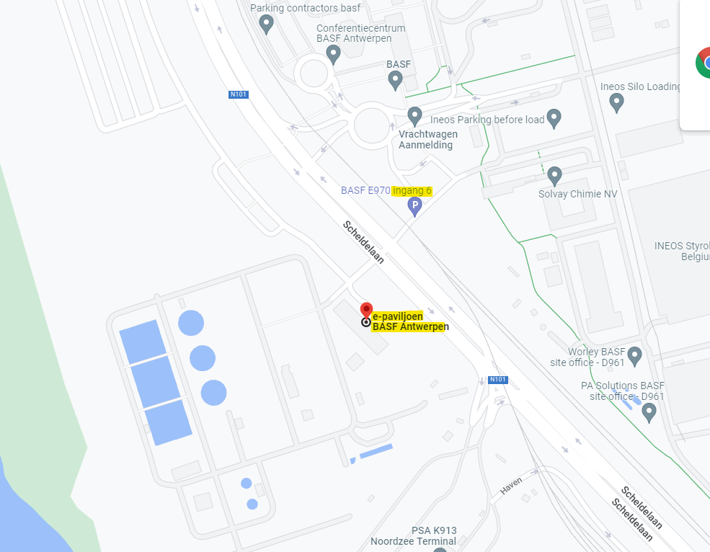
BASF Antwerpen N.V.
Haven 725
Scheldelaan 600
2040 Antwerpen - Belgium
Trilateral strategy for the chemical industry
The TRILOG or ‘Trilateral strategy for the chemical industry’ is a cross-border cooperation between the Netherlands, Flanders and North Rhine-Westphalia. In a global competitive environment that is changing drastically, the trilateral chemical industry faces fundamental economic, environmental and technological challenges. To prepare for the future, capture the benefits of a growing chemical industry and remove existing bottlenecks for this development, an important strategic process had been launched in 2017. North Rhine-Westphalia, the Netherlands and Flanders agreed on a joint vision on the future development of their flagship industry – the chemical industry.
Infrastructure (trilateral-chemical-region.eu)

